(Approx. 775 words)

Kretchmar's Korner
A Mighty Mite External SSD
David Kretchmar, Hardware Technician
Sun City Summerlin Computer Club
https://www.scscc.club
dkretch ** gmail.com

A mystery package addressed to me appeared at our front door a few months ago. This is not an uncommon occurrence at our home; at least once a month, I forget I have ordered an item, and its arrival is a pleasant surprise. I have no idea what was in the package until I opened it, and fortunately, I still remember ordering the item.

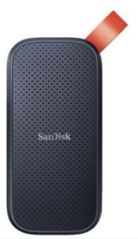
Something different happened to me this time. I excitedly cut open the mystery padded envelope and found a wee SanDisk USB 3.2 Gen2 portable SSD. I was further delighted when I noticed the drive had a one Terabyte capacity.

It was 1/3 the size and a fraction of the weight of a mechanical external USB drive thanks to its M.2 SSD. Cool, I thought – this is something I can use. I guessed I might have ordered this late at night, maybe after a couple of sips of wine, and forgotten about it.

I soon realized my mystery package was the SanDisk SSD external drive I had volunteered to test for Newegg.com, an online reseller. YES! A free useful item is an even better deal than the drive costs at online sellers.

I plugged the SSD into my tower using the cable provided: USB-C (external drive end) to the USB Type-A (backward compatible with any standard USB port). It was instantly recognized.

Real-world speed
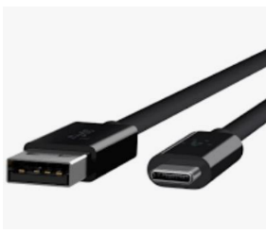
The drive is advertised as having a READ speed of up to M.2 SSD 520 Mb/second. I copied a 2 Gb file from my tower's internal M.2 SSD to the SanDisk external drive to test the real-world speed of the drive. It transferred data at about 120 MB per second, 3X faster than copying the same data to my older external mechanical Samsung external drive. This was a little slower than I anticipated since SSDs generally run from 4 to 10 times faster than a mechanical drive.

My tower's USB is mostly the older and slower 3.1 version, which I'm sure was the factor in the drive's lack of speed. I am disappointed with the data transfer speed because of the USB 3.1 and maybe the USB C to USB A cable. My tower, which is just a few months old, does have one Type-C USB port, but since I do not have a newer USB C to USB C cable, I could not test that transfer speed. This cable costs about $10 - $20 at Amazon or Newegg.

The Vault

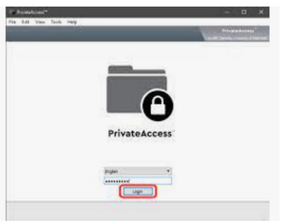
The Samsung external SSD M.2 drive comes with an ingenious encryption scheme they call PrivateAccess with the encrypting software installed on the drive itself. This software will ONLY run off the external drive, further increasing the device's security. Transferring data to the external drive vault is a drag-and-drop procedure using the drive's built-in encryption software. There is no back door into the vault. As you would expect, if you forget your password, the data in the vault is gone forever. This drive will dedicate only the amount of space required for encrypted data, so the balance of storage space is available for nonencrypted storage.

The curse and blessing of backward compatibility

The drive would be much faster on newer computers if it included a USB C to USB C cable and a USB C to USB A cable. Other external SSDs I have seen advertised come with the USB C to USB C cable. Obviously, the USB C - USB A cable is required for backward compatibility and is the most useful connection today. Still, any new computer you buy now should include a USB-C outlet. If you are offered a computer without a USB Type-C port, you know that system is likely old stock, and you should make your buying decision accordingly.

The USB cable furnished with this drive is only one foot long. This is adequate for functionality but too short for real-world usage. As a result, I prefer the external drive sitting on top of my tower rather than dangling at its side.

Conclusions

This is a remarkable amount of fast external storage for the money. A USB Type-C to USB Type-C is necessary if your computer has a USB Type-C outlet. At the risk of boring repetition, a computer user who does not back up important files will very possibly lose those files due to a hardware failure or mischief caused by a ransomware infection.

The Vault feature of this drive is an outstanding personal privacy consideration. It would also be impossible for any ransomware software to corrupt files stored in the Vault.

